Passive PoE Switch

⚠️ What is a Passive PoE Switch?
# Source: Chatgpt (GPT‑5 Mini) at [12/18/2025]
A Passive PoE Switch is a type of Power over Ethernet switch that supplies a constant, unregulated voltage over Ethernet cables — without negotiating with connected devices. Unlike active PoE switches, it does not follow IEEE standards (like 802.3af/at/bt) and always sends power, regardless of whether the connected device needs it or not.

🔌 How Passive PoE Works
# Source: Chatgpt (GPT‑5 Mini) at [12/18/2025]
- It sends a fixed DC voltage (commonly 24V or 48V) directly over specific Ethernet pins.
- It does not detect if the device supports PoE — it just powers it anyway.
- This makes it cheaper, but riskier if used improperly.

⚙️ Key Characteristics
# Source: Chatgpt (GPT‑5 Mini) at [12/18/2025]


Feature | Description
No Handshake | No negotiation with the device — power is always sent.
Fixed Voltage | Supplies a set voltage (e.g., 24V or 48V) continuously.
Non-Standard | Does not conform to IEEE PoE standards like 802.3af/at.
Lower Cost | Typically cheaper than active PoE switches.
Simpler Design | Often used in specialized or proprietary setups (like MikroTik or Ubiquiti).

⚠️ Important Warning
# Source: Chatgpt (GPT‑5 Mini) at [12/18/2025]
Passive PoE can damage non-PoE devices if plugged in, because it does not check compatibility. Always ensure:
- The device is rated for the voltage used (e.g., 24V Passive PoE).
- You’re using compatible equipment (usually from the same vendor).

🧱 Use Cases for Passive PoE Switches
# Source: Chatgpt (GPT‑5 Mini) at [12/18/2025]


Where Used | Why
Small wireless setups | For powering wireless bridges or access points
Rural ISP installations | To run long Ethernet + power cables to antennas
Proprietary systems | Often designed for specific hardware (e.g., MikroTik RouterBOARDs)

🆚 Passive PoE vs Active (802.3af/at/bt) PoE
# Source: Chatgpt (GPT‑5 Mini) at [12/18/2025]
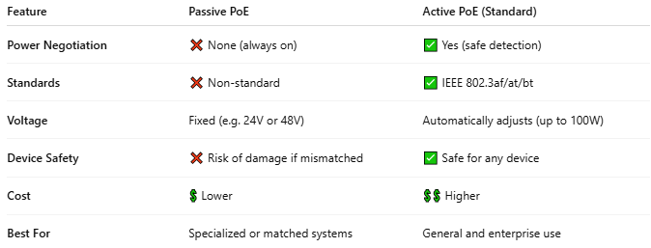

Feature | Passive PoE | Active PoE (Standard)
Power Negotiation | ❌ None (always on) | ✅ Yes (safe detection)
Standards | ❌ Non-standard | ✅ IEEE 802.3af/at/bt
Voltage | Fixed (e.g. 24V or 48V) | Automatically adjusts (up to 100W)
Device Safety | ❌ Risk of damage if mismatched | ✅ Safe for any device
Cost | 💲 Lower | 💲💲 Higher
Best For | Specialized or matched systems | General and enterprise use

✅ When to Use a Passive PoE Switch
# Source: Chatgpt (GPT‑5 Mini) at [12/18/2025]
- You are using all PoE-compatible devices with known voltage requirements
- You want lower cost in a controlled environment
- You are working with vendor-specific solutions (e.g., Ubiquiti AirMax or MikroTik gear)

